**Lambda Function**

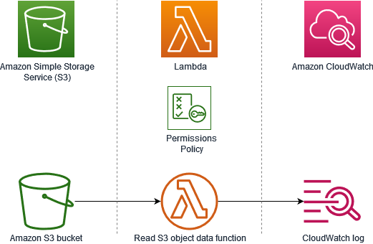

Amazon Simple Storage Service (S3) is a cloud-based storage service that offers persistence and versioning of files, as well as standard APIs to access and upload files. AWS Lambda is Amazon Web Services’ serverless compute service which enables you to run code in response to events or input, without having to provision or manage virtual servers. This blog post focuses on the use of an S3 trigger for invoking a Lambda function. This post will teach you how to set up an S3 trigger that invokes your Lambda function, effectively creating a new type of ETL (Extract, Transform, and Load) workflow using these two services. An ETL workflow is a sequence of operations that reads data from one source, writes it to another source, and transformations it along the way.

# What is an S3 Trigger?

An S3 trigger is a rule that instructs S3 to invoke a specified Lambda function whenever an event occurs. The most common types of events are bucket-related events, such as object creation, deletion, or modification. You can also trigger an S3 event based on metadata or an S3 event put operation. The S3 trigger rule specifies the conditions for triggering a Lambda function. You can use the rule to filter events, specify the time range for triggering, and define the number of events for execution. When S3 invokes a Lambda function, it provides the following information as part of the event payload: The source bucket name and the event type (such as object created, object deleted, etc.). A timestamp that indicates when the event occurred. Granular access control list (ACL) permissions that define who can access the object and what operations they can perform.

# What is AWS Lambda?

AWS Lambda is a serverless compute service that runs your code in response to events or S3 actions without having to provision or manage servers. When Lambdas are invoked, they’re executed in parallel, using containers optimized for speed, reliability, and scalability. AWS Lambda functions can be triggered by many different events, including other AWS services, HTTP requests, and AWS CloudWatch Events. While Lambda function execution times vary, they are billed by the second. Your function is charged whenever it’s running, even if it’s only running for a short time.

**Create a bucket and upload a sample object**

1. Open the Amazon S3 console

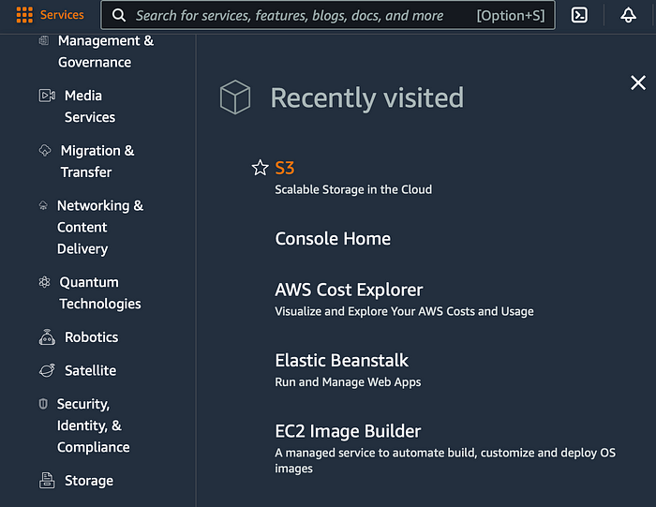

AWS Scalable Storage in the Cloud

2. Choose **Create bucket**

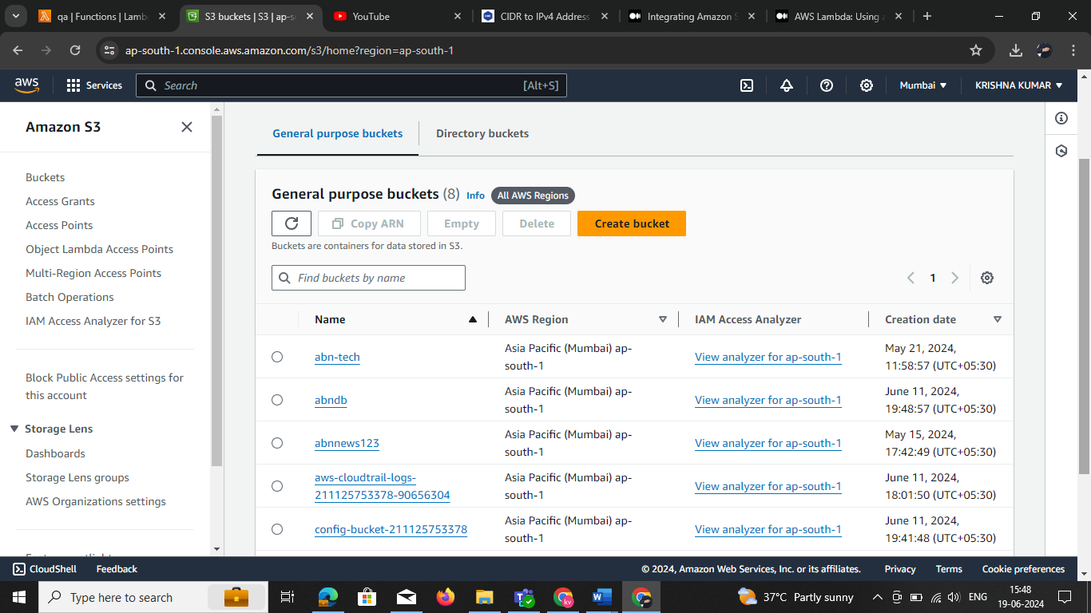

Create a S3 bucket

3. Under **General configuration**, do the following:

* For **Bucket name**, enter a unique name.
* For **AWS Region**, choose a Region. Note that you must create your Lambda function in the same Region.

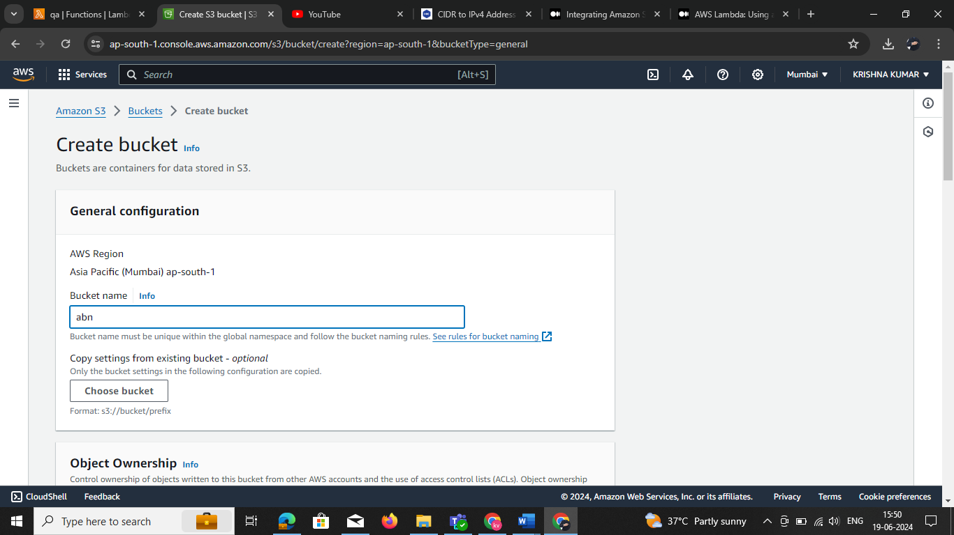

4. Choose **Create bucket**.

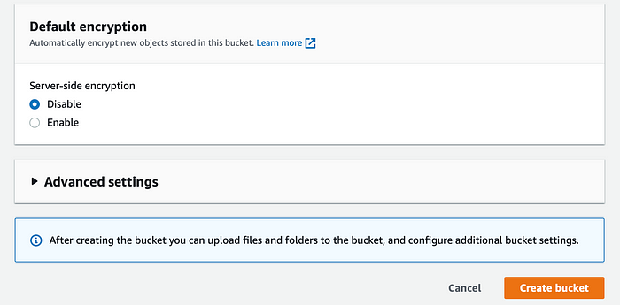

Amazon S3 displays the **Buckets page** after you create a bucket, which lists all buckets in your account in the current region.

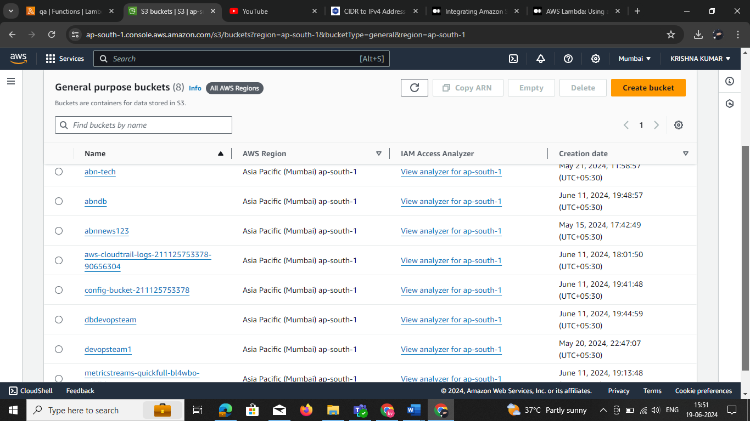

**Create the Lambda function**

1. Open the [**Functions page**](https://console.aws.amazon.com/lambda/home#/functions) of the Lambda console.

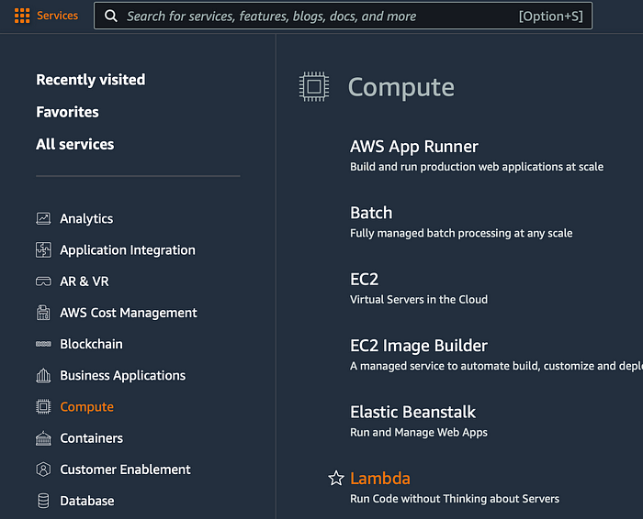

AWS Lambda — Run Code without Thinking about Servers

1. Choose **Create function**.

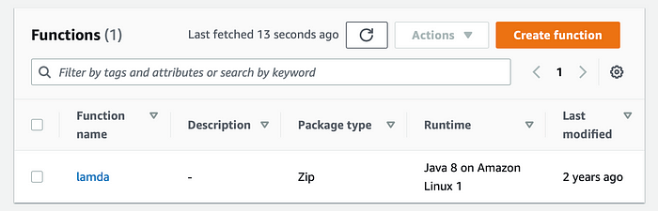

Create Lambda function

2. On the Create function page, select **any one in the below**and click **Configure**.

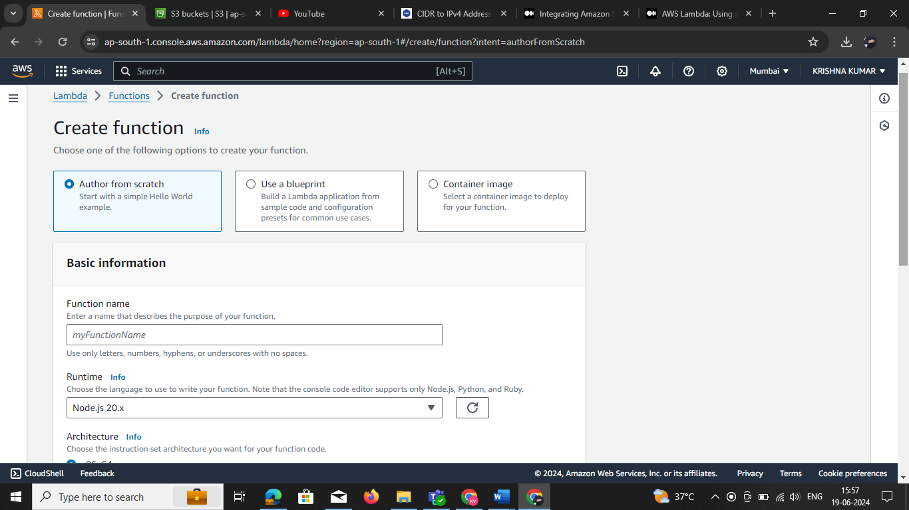

AWS Create Lambda function page select the runtime env select one

3. Under **Basic Information**, enter the information as follows: we need to create role you have all existing role

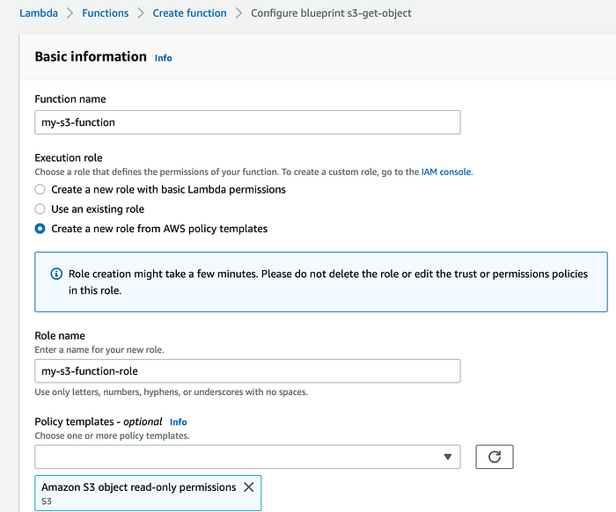**NOTE: using the new role and existing role set this custom polices s3fullacess , CloudWatchFullAccess ,**

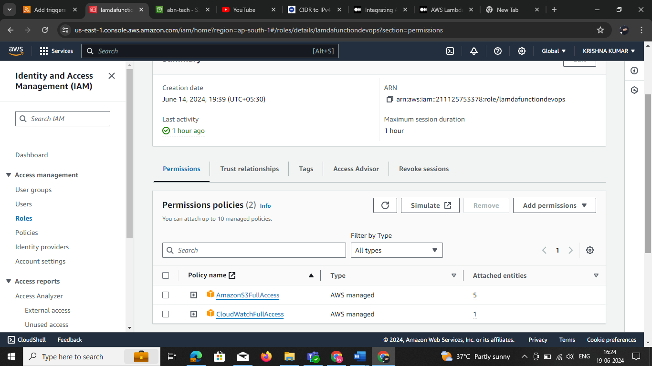

4. Under **S3 trigger**, choose the S3 bucket that you created previously.

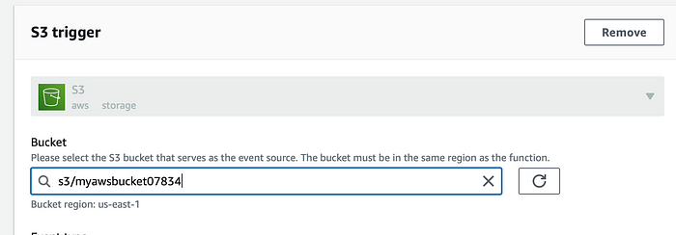

AWS S3 trigger

Set up the tigger click the add trigger

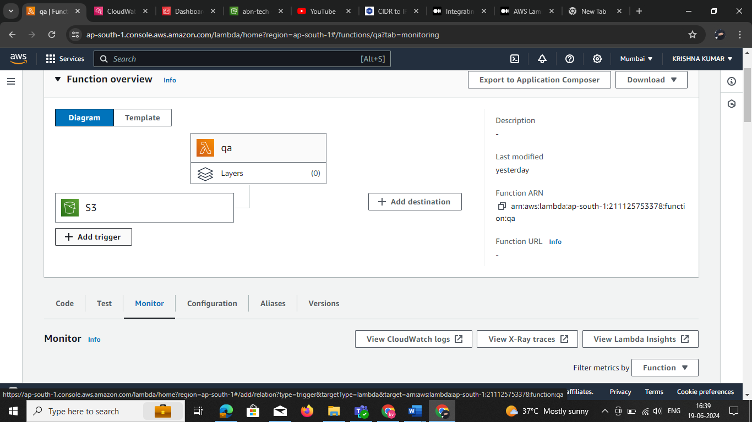

Select the tigger type in below

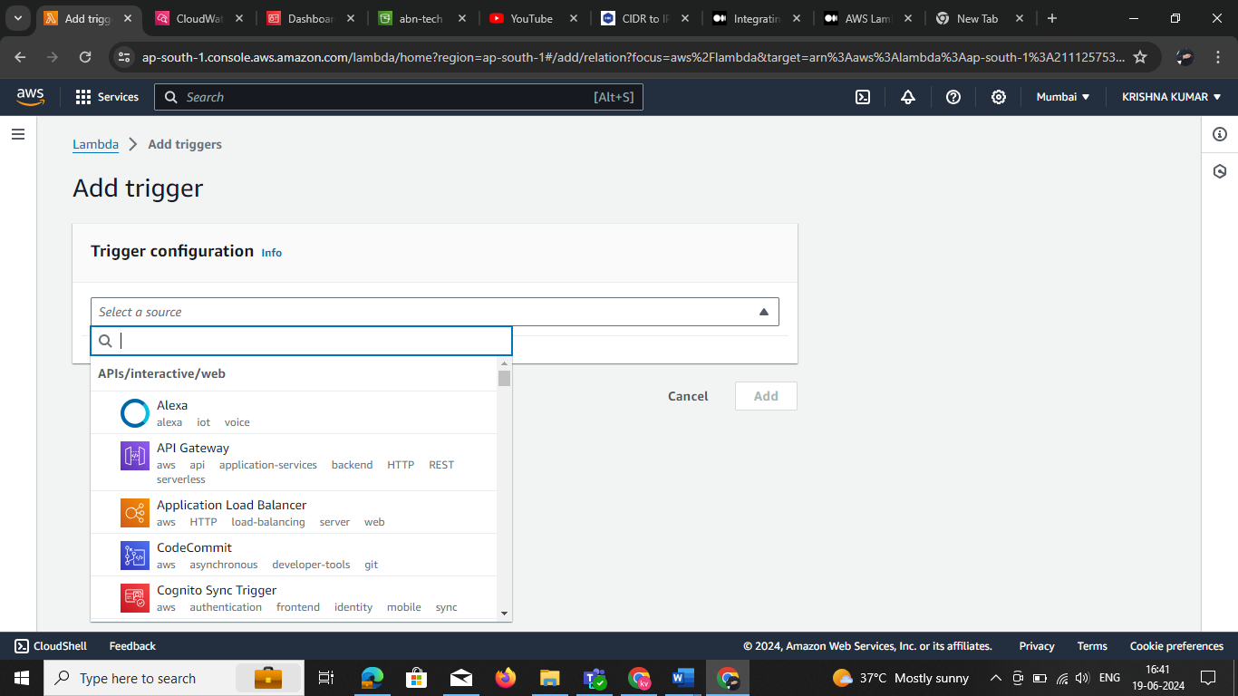

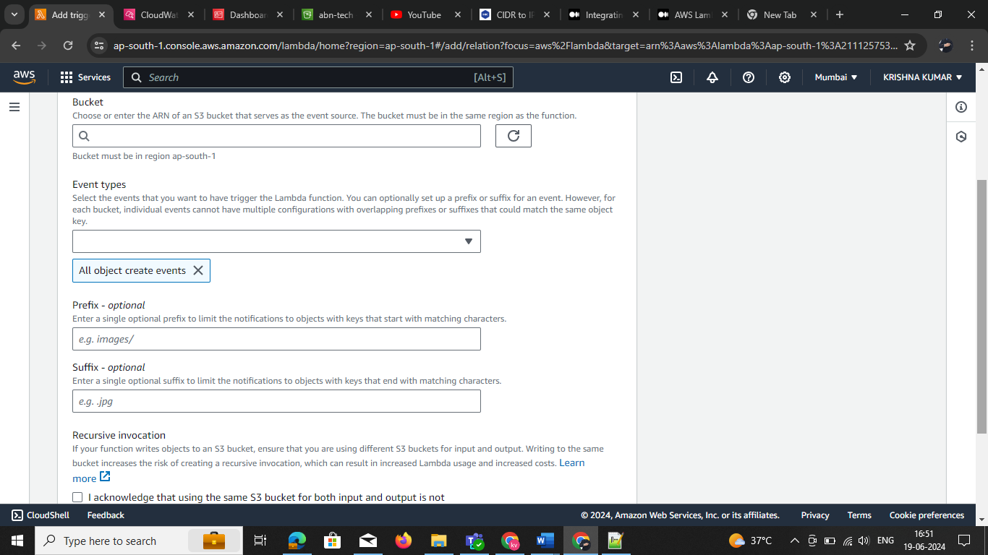

5- Choose **Create function**.

When you upload a file to the **Amazon S3 source bucket**, the Lambda function is invoked using the **S3 trigger**.

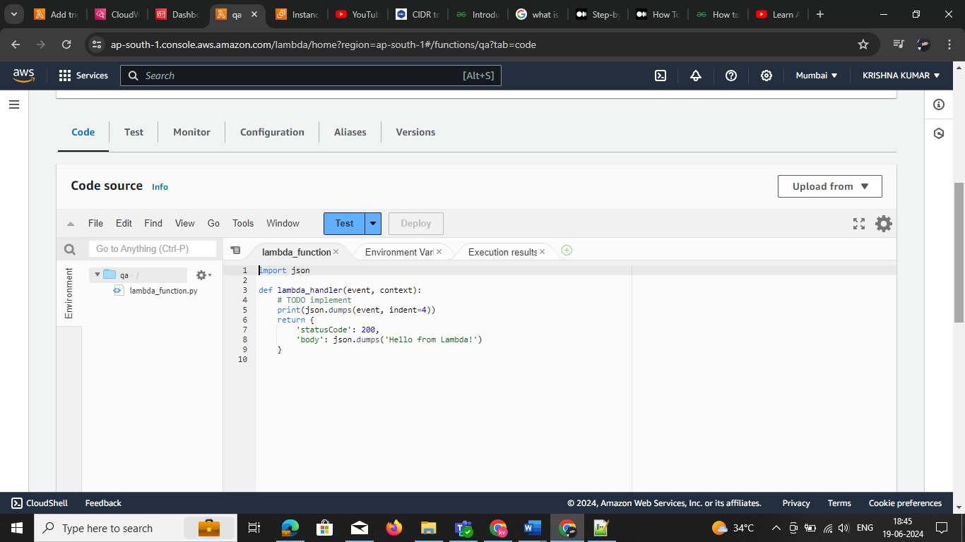Choose the **Monitor** tab to verify that the function ran once for each file that you uploaded. This page displays Lambda’s CloudWatch metrics, and the **Invocations** graph should equal the **number of files** you uploaded to Amazon S3.AWS Go to your lambda function and

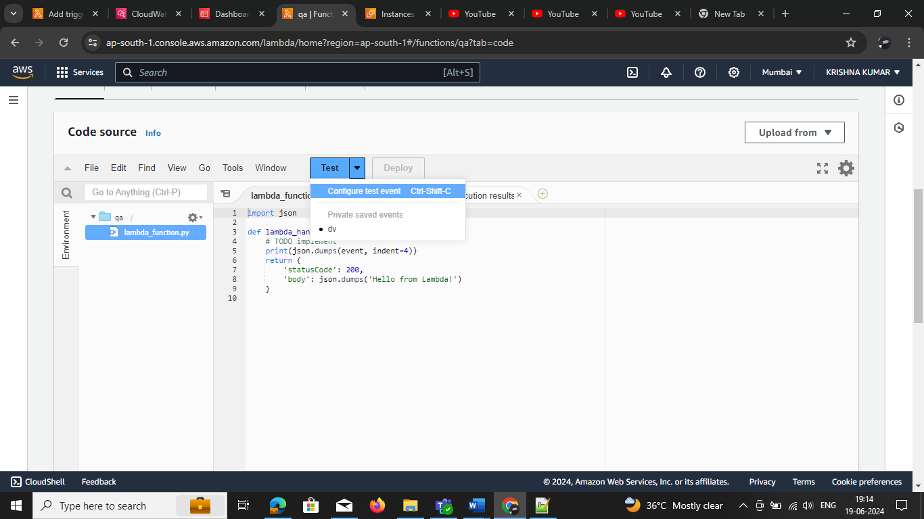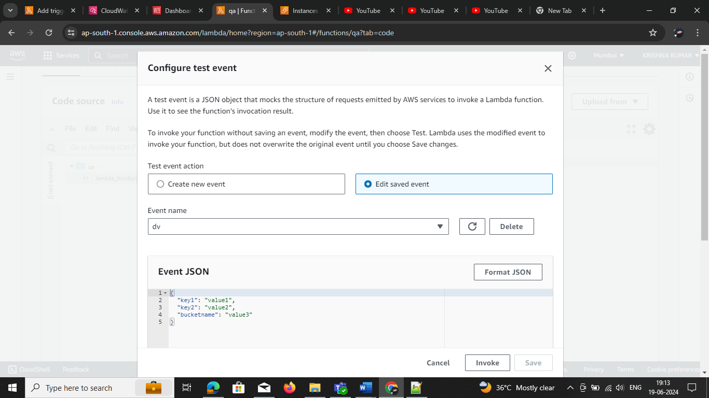

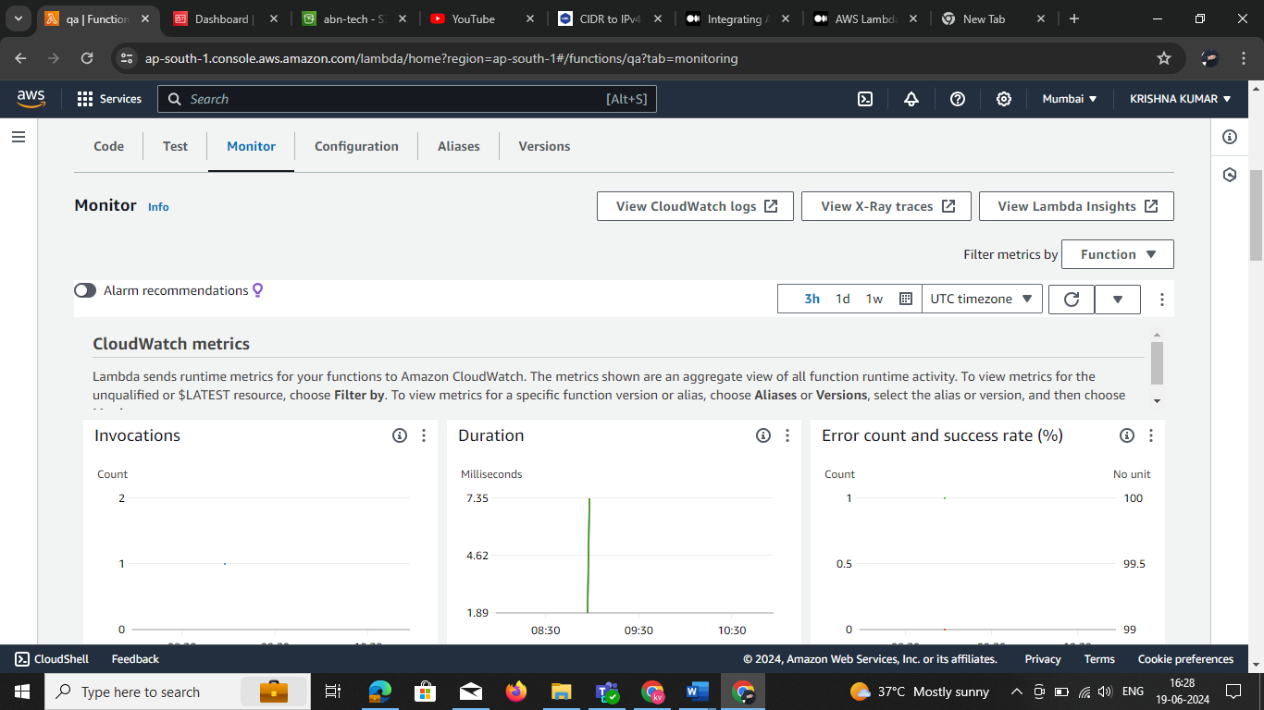

Click on the view CloudWatch logs this is show below page data and time, click select the logs get clear view Log **events**

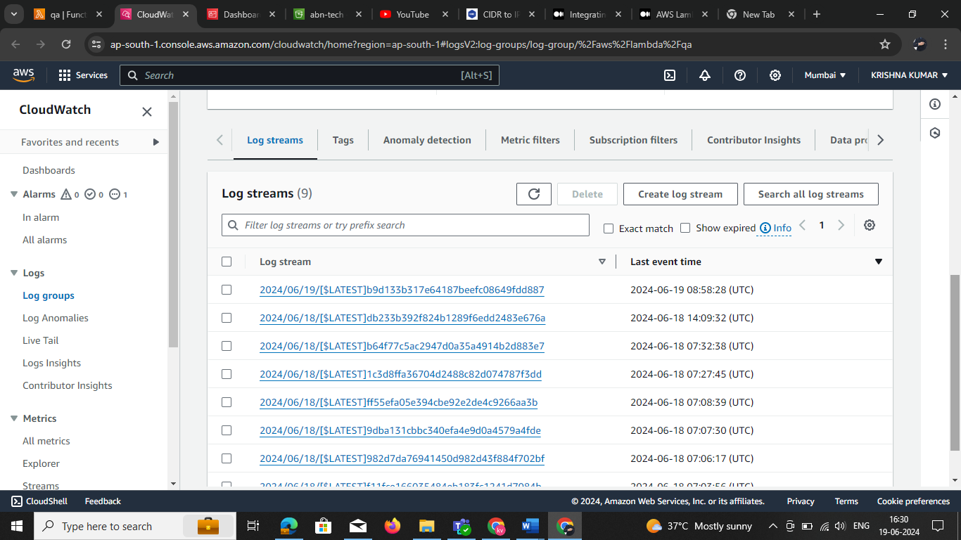

Select the logs view the clear log

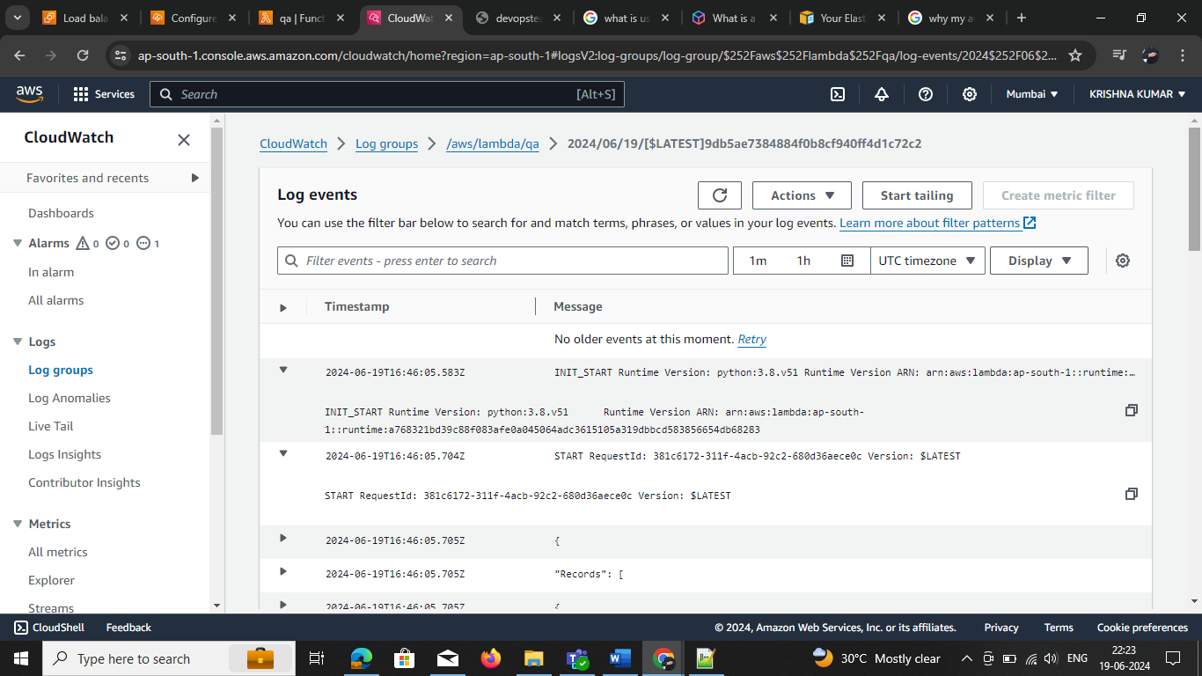

**S3(Amazon Simple Storage Service)**

S3 stands for Simple Storage Service. S3 is like a virtual drive to store and retrieve data. According to the AWS definition, “You can use Amazon S3 to store and retrieve any amount of data at any time, from anywhere on the web.”

* Files in S3 are stored in buckets (Buckets are like folders)
* S3 is object-based storage (Like Images, videos, documents etc)
* Buckets names should be unique globally because when we create a bucket in S3 it will have a unique URL.
* It’s a good practice creates buckets in the nearest region to you or for your customers.

S3 stands for Simple Storage Service. S3 is like a virtual drive to store and retrieve data. According to the AWS definition, “You can use Amazon S3 to store and retrieve any amount of data at any time, from anywhere on the web.”

* Files in S3 are stored in buckets (Buckets are like folders)
* S3 is object-based storage (Like Images, videos, documents etc)
* Buckets names should be unique globally because when we create a bucket in S3 it will have a unique URL.
* It’s a good practice creates buckets in the nearest region to you or for your customers.

S3 stands for Simple Storage Service. S3 is like a virtual drive to store and retrieve data. According to the AWS definition, “You can use Amazon S3 to store and retrieve any amount of data at any time, from anywhere on the web.”

* Files in S3 are stored in buckets (Buckets are like folders)
* S3 is object-based storage (Like Images, videos, documents etc)
* Buckets names should be unique globally because when we create a bucket in S3 it will have a unique URL.
* It’s a good practice creates buckets in the nearest region to you or for your customers.

## **What is Amazon S3?**

Amazon S3 is a Simple Storage Service in[AWS](https://www.geeksforgeeks.org/aws-tutorial/)that stores files of different types like Photos, Audio, and Videos as Objects providing more scalability and security to. It allows the users to store and retrieve any amount of data at any point in time from anywhere on the web. It facilitates features such as extremely high availability, security, and simple connection to [other AWS Services.](https://www.geeksforgeeks.org/top-aws-services/)

## What is Amazon S3 Used for?

Amazon S3 is used for various purposes in the Cloud because of its robust features with scaling and Securing of data. It helps people with all kinds of use cases from fields such as Mobile/Web applications,[Big data,](https://www.geeksforgeeks.org/what-is-big-data/) [Machine Learning](https://www.geeksforgeeks.org/ml-machine-learning/) and many more. The following are a few Wide Usage of Amazon S3 service.

* **Data Storage:**Amazon s3 acts as the best option for scaling both small and large storage applications. It helps in storing and retrieving the data-intensitive applications as per needs in ideal time.
* **Backup and Recovery:**Many Organizations are using Amazon S3 to backup their critical data and maintain the data durability and availability for recovery needs.
* **Hosting Static Websites:**Amazon S3 facilitates in storing HTML, CSS and other web content from Users/developers allowing them for hosting Static Websites benefiting with low-latency access and cost-effectiveness. To know more detailing refer this Article – [How to host static websites using Amazon S3](https://www.geeksforgeeks.org/how-to-host-static-website-using-aws-s3/)
* **Data Archiving:**[Amazon S3 Glacie](https://www.geeksforgeeks.org/what-is-amazon-glacier/)r service integration helps as a cost-effective solution for long-term data storing which are less frequently accessed applications.
* **Big Data Analytics:**Amazon S3 is often considered as data lake because of its capacity to store large amounts of both structured and unstructured data offering seamless integration with other AWS Analytics and AWS Machine Learning Services.

## **What is an Amazon S3 bucket?**

Amazon S3 bucket is a fundamental Storage Container feature in AWS S3 Service. It provides a secure and scalable repository for storing of Objects such as Text data, Images, Audio and Video files over AWS Cloud. Each S3 bucket name should be named globally unique and should be configured with ACL (Access Control List).

## **How Does Amazon S3 works?**

Amazon S3 works on organizing the data into unique S3 Buckets, customizing the buckets with Acccess controls. It allows the users to store objects inside the S3 buckets with facilitating features like versioning and lifecycle management of data storage with scaling. The following are a few main features of Amazon s3:

### **1. Amazon S3 Buckets and Objects**

**Amazon S3 Bucket:** Data, in S3, is stored in containers called buckets. Each bucket will have its own set of policies and configurations. This enables users to have more control over their data. Bucket Names must be unique. Can be thought of as a parent folder of data. There is a limit of 100 buckets per AWS account. But it can be increased if requested by AWS support.

**Amazon S3 Objects:** Fundamental entity type stored in AWS S3. You can store as many objects as you want to store. The maximum size of an AWS S3 bucket is 5TB. It consists of the following:

**Comparison of different AWS Storage types:**

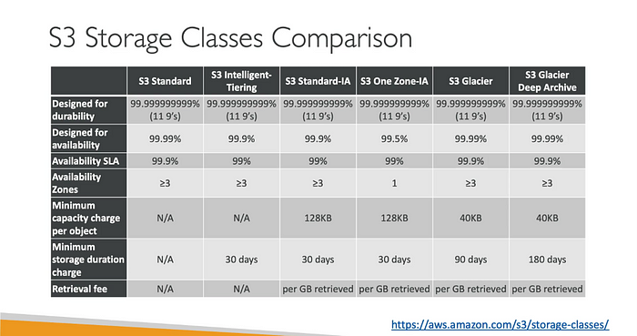

**Step 1: Navigate to the S3 Service**

Once you’re logged in to the AWS Management Console, search for and select the S3 service. This will take you to the S3 dashboard, where you can manage your buckets and objects

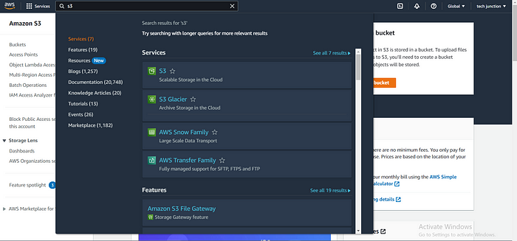

**Step 2: Create a New Bucket**

To create a new bucket, click on the “Create bucket” button. You will be prompted to provide a unique name for your bucket. Keep in mind that the bucket name must be globally unique across all existing buckets in S3.

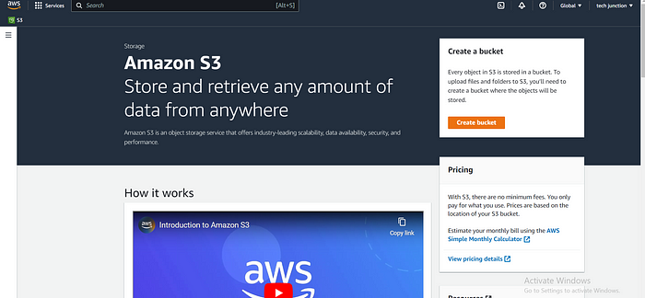

**Step 3: Configure Bucket Properties**

After naming your bucket, you’ll need to configure its properties. This includes selecting the region where your bucket will be located and setting up optional features such as versioning, logging, and tags. Choose the appropriate settings based on your requirements.

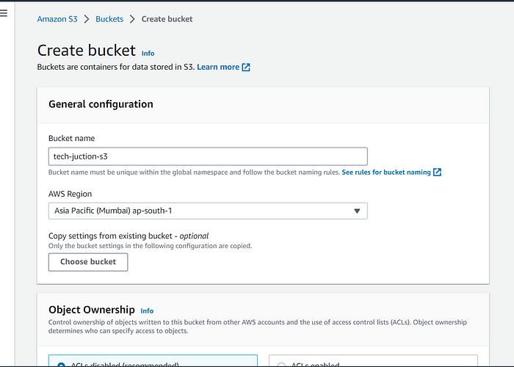

**Step 4: Set Permissions**

In this step, you can define access permissions for your bucket. AWS offers a flexible and granular access control mechanism using AWS Identity and Access Management (IAM) policies. You can specify who can access your bucket and what operations they can perform.

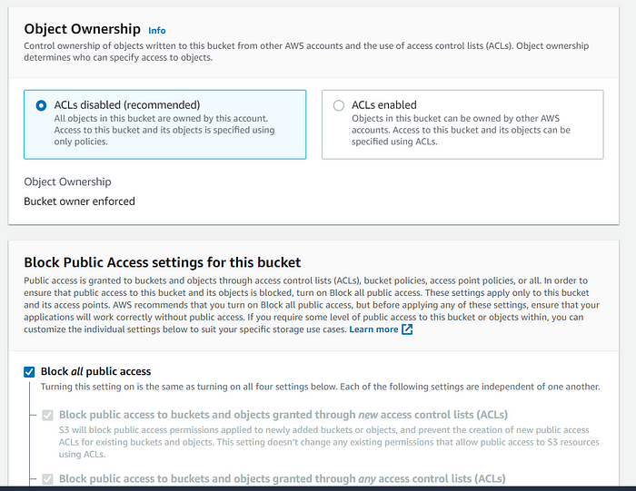

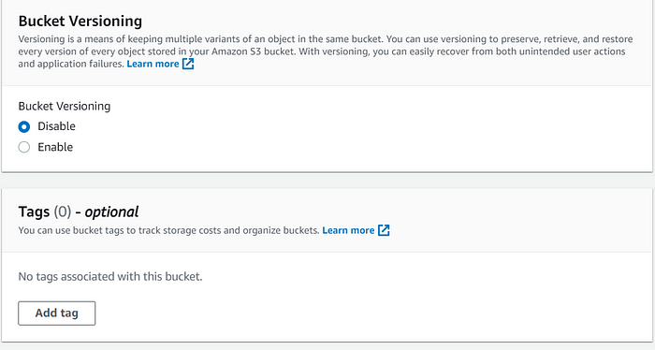

**Step 5: Review and Create**

Before creating the bucket, review the configuration settings you’ve made so far. Double-check the bucket name, region, properties, and permissions. If everything looks good, click on the “Create bucket” button to create your S3 bucket.

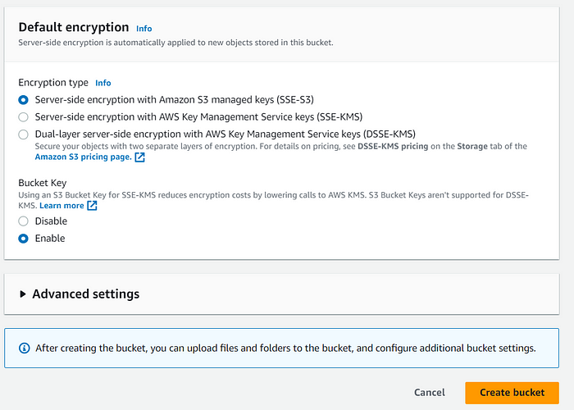

Then your can see your bucket hear

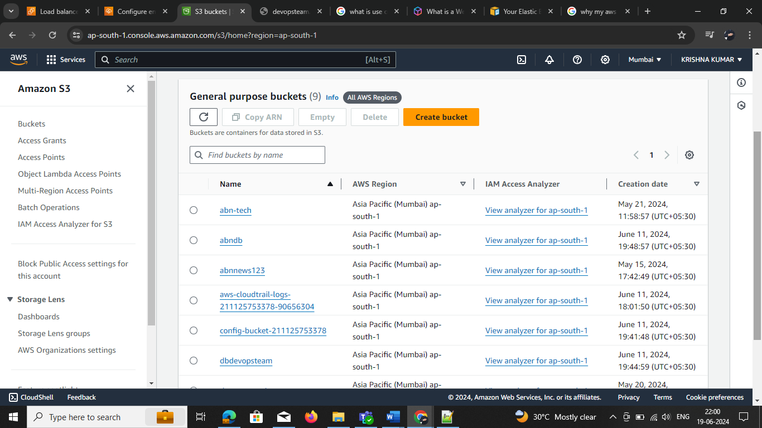

**How to change the s3 bucket class**

**Select bucket 🡪 go to select the all OBJ, single Objects in 🡪 select the Action 🡪Edit storage class**

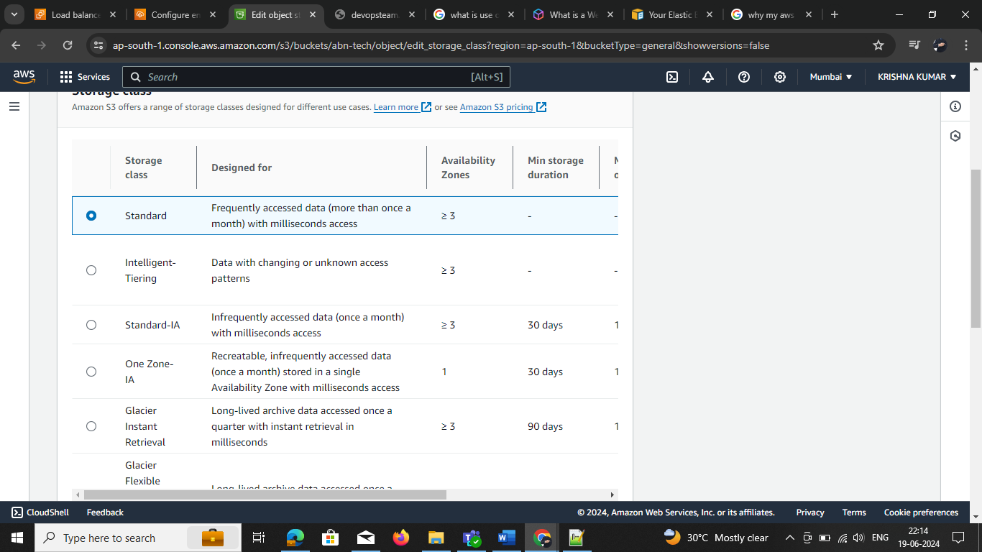

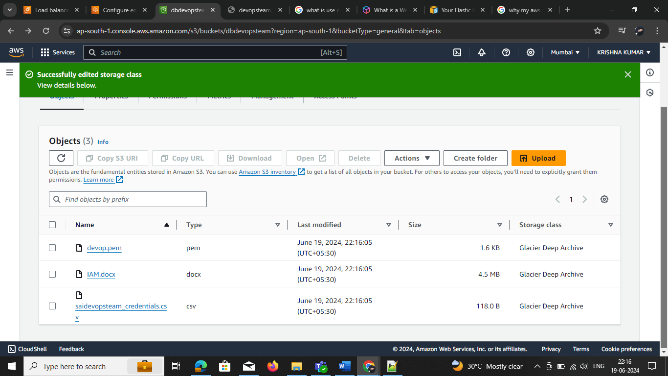**Now the storage class has change**